ES - Sprint 2 – Code Smells 1

**Primitive Obsession**

This code smell occurs when we rely too much on the use of built-in types (or primitives like int, long, float or strings). Although these primitives will be needed in the code, they should exist at the lowest levels of the code. To fix this may be possible to logically group some of them into their own class. Even better, move the behaviour associated with this data into the class too.

* 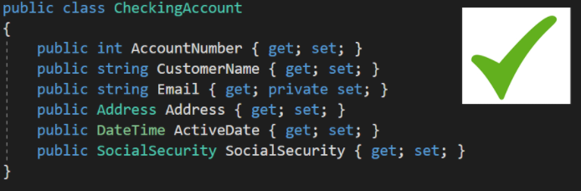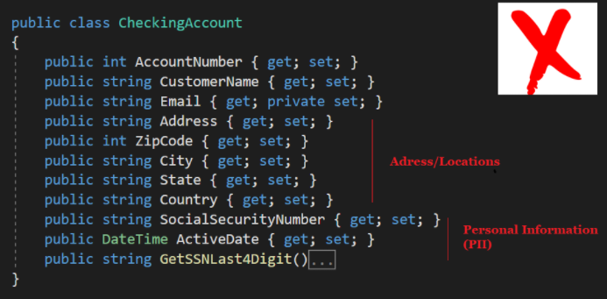**Code Snippet (example)**

Instead of creating a primitive for each method (first image) we can create some classes, in this case Adress and SocialSecurity (second image), and create there the related primitive methods, in order to create only two primitives (of type Adress and SocialSecurity) instead of seven like (String Adress, City, State, etc).

* **Code Location**

Path:

*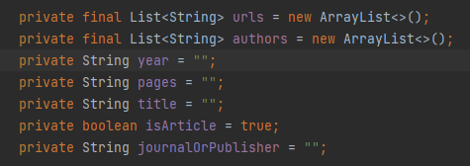“src\main\java\org\jabref\gui\bibtexextractor\BibtexExtractor.java”*

**Justification**

Like we can see is present a primitive obsession because there are too many primitives (String, boolean) that can be in one class, creating then only one variable in this one, which type is the class we created.

**Refactoring Proposal**

In this case we should create a class that stores the primitives and create methods to get those primitives and set them. This way we trade a lot of primitives to an object.

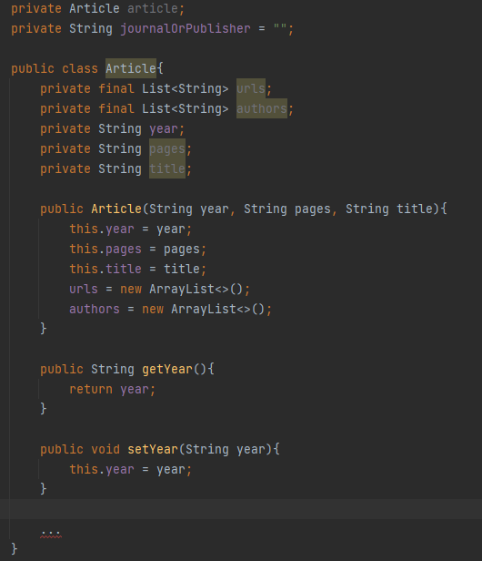Example: